**ACADEMIC TRAINING**

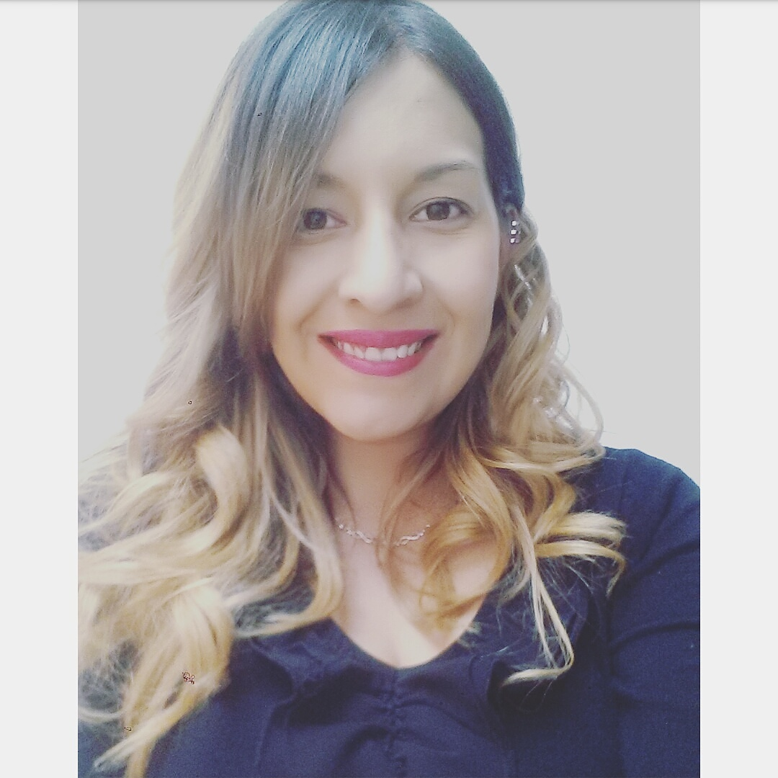

**GRACIELA**

**MANDUJANO JURADO**

Single.

25 years

October 3,1991

CURP

MAJG911003MGTNRR03

RFC

MAJG911003DG3

Acámbaro Gto.

Hidalgo #25 Los Fresnos

C.P 38738

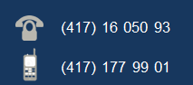

Date of elaboration 04/21/2010

Update date

01/25/2017

gramajuja@gmail.com

September 2013- august 2016

Universidad Tecnológica de León

ADRESS:

Highway Acámbaro-Tarandacuo km8, cp. 38601

DOCUMENTS OBTAINED**:**

Degree in process.

August 2006 - july 2009

Colegio Nacional de Educación Profesional Técnica Bachiller

ADRESS:

Highway Acámbaro- Salvatierra, km 2.5

DOCUMENTS OBTAINED**:**

Certificate, degree y profesional certificate.

August 2003 - july 2006

Escuela Secundaria General Elías Macotela García

ADRESS:

Av. Guerrero 124A, downtown area, Acámbaro, Gto.

DOCUMENTS OBTAINED**:**

Certificate.

**OBJETIVE PERSONAL**

Work hard to achieve economic stability.

**OBJETIVO PROFESIONAL**

To establish and consolidate myself in an organization, to apply my acquired knowledge in the areas that correspond to me of the company, and to develop myself professionally for the good performance of the assigned functions.

**WORK EXPERIENCE**

**Company name:** General Hospital of Salvatierra

**Job title:** Administrative

**Start date:** 16 de june 2014 **end date:** Still working.

**Main activities:**

* Capturing patient outflows, injury sheets, emergencies, deaths, birth, through different platforms and managing databases for each platform.
* Capture of the consultations carried out by each physician within the Hospital Unit, delivering final reports every month.
* Representative of the department to attend training on updates, meetings.
* Responsible for providing training to staff if necessary.
* Responsible for reviewing the SAEH system once a month.

**Highlights such activities as:**

* Motivation to the work team to update some working methods.
* Development of tables in Microsoft Excel for the agility of data capture.

**PROGRAMS**

* Microsoft Word
* Microsoft Excel
* Microsoft Power Point
* Blender
* Camtasia
* Macromedia Fireworks
* Netbeans IDE

**PROGRAMMING LANGUAGESI**

* C++
* Java
* PHP

**QUALIFICATIONS AND SKILLS**

* Capacity for teamwork.
* Ability to deal with people.
* Proactivity.
* Leadership.
* Initiative
* Responsability.
* Problem resolution.
* Working under ethics.

**AVAILABILITY**

From 15:00 hrs. onwards.

**IDIOMS**

Basic english